**Development of Problem Statement**

**Project Description :**

The project is to Create a web page for “**kindergarten**” and it has 4 pages Home, about, Programs, Contact us And we used Bootstrap & CSS in this project

**Identify the Problems :**

1. Navbar is not full-screen width even when I use “**w-100**”



1. I don’t know how to move the “home, about …” part to the right side in Nevbar.



1. Now I don’t know what to do about this background as you can see this background it has 2 layers of color in the back and it also has this big image and contain over it

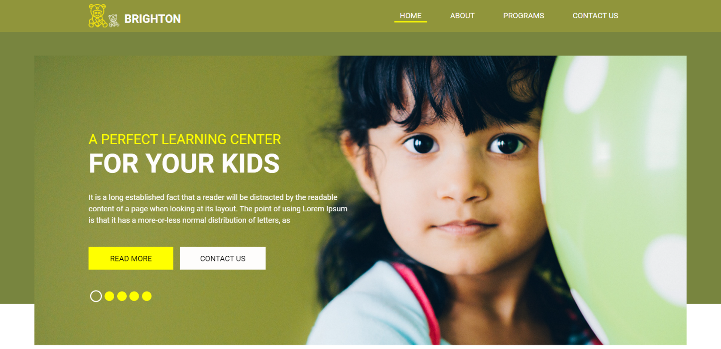

**Identify the solution & Responsibility :**

1. Move your navbar outside “**div. container**”.

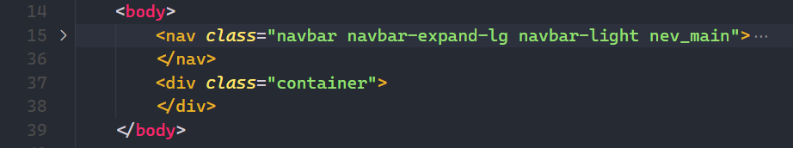

1. Move your **hyperlink** outside of those divs.

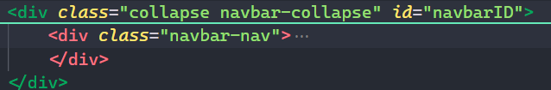

1. Mack you’re div **relative** so you can move.

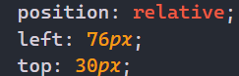

**Action steps :**

1. I tried to change the class “**navbar-expand**” and it’s also tried its other option such as
   1. “**navbar-expand-sm**”
   2. “**navbar-expand-md**”
   3. “**navbar-expand-lg**”
   4. “**navbar-expand-xl**”. but it don’t work,
   5. then I tried to move my navbar outside “**div. container**” and it **worked**.



1. I tried to add “**align-content-end**” but it didn’t work, then I research it on the Bootstrap site and this is how they use it.

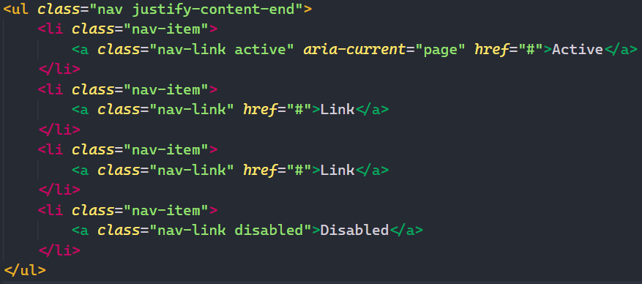

So I did this and this is the outcome :

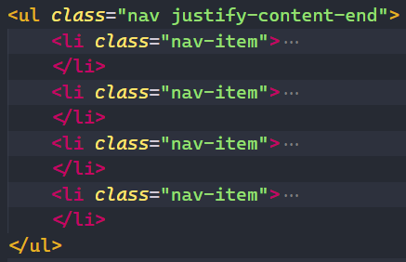



1. In this we use **position: relative,** so you canmackyour div and move anywhere you want in this we have to move from **top 30px** and from **left 76px** so your div will get in this position, and the background image is set and background-size is cover.

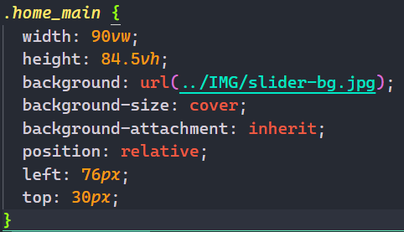



**Conclusion :**

By working on this project we got the **privilege** tolearn more deeply about **Css & Bootstrap**. Our knowledge is expended about those prospective. And it’s good to work on this type of mini project to improve our skills.